A-VIEW Server Installation Guide

(For v 4.0)

Amrita

E-Learning Research Lab

Amrita e-learning research lab

Contents

1. Introduction 4

2. Setting up your Development Environment 4

3. Checking out Source Code 4

4. Compiling the Java Server Tomcat Project 5

5. Validating the A-VIEW Server within Eclipse 10

6. To Export the Java code as War file 15

7. Installing the various Server Roles 17

7.1 Content Server (Windows) 17

7.2 Video Server / Collaboration Server 17

7.3 Java Server & Database Server 17

7.4 Special Setup Steps for Windows 17

8. Configuration Instructions 18

8.1 Video / Collaboration Server 18

8.2 Java Server & Database Server 18

8.2.1 Java Configuration 18

8.2.2 Mysql Configuration 21

8.2.3 Tomcat 22

8.3 Content Server 22

8.3.1 Wamp (Apache Web Server) 22

8.3.2 PHP (Content Server) 22

8.3.3 Print2Flash 23

8.3.4 Speedtest (Optional) 24

# Introduction

This document explains the steps involved in setting up the A-VIEW Server. These are the high-level steps:

* Setup the development environment
* Checkout the code from Git
* Compile the Java Server.
* Install the Servers
* Configure the Servers

These are explained in the rest of the document in detail. Prior to doing these, it is recommended that you follow the instructions in the **A-VIEW Server Pre-Requisites** for creating your topology and installing the necessary pre-requisite software.

# Setting up your Development Environment

Please complete installation / configuration of these steps in your development environment first:

1. Install Eclipse Indigo
2. Install JDK Version 7
3. Install Tomcat 7.0.41
4. Install MySQL5.5.16
5. Install Git

# Checking out Source Code

Git clone the following repositories to your local development computer.

* aview-db-mysql
* aview-server-tomcat
* aview-content-php
* aview-video-fms

# Compiling the Java Server Tomcat Project

Once the prerequisites are taken care, please follow the below steps to import the project into workspace.

1. **Open Eclipse IDE.**
2. **From the Eclipse IDE, select *File*and choose *Import.* (Refer Fig: 1)**

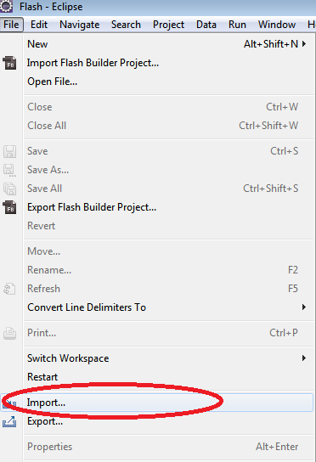

Fig: 1 – Select Import from menu

1. **In the *Import wizard,* select *Existing Projects into Workspace* in *General* and click *Next* Button.**

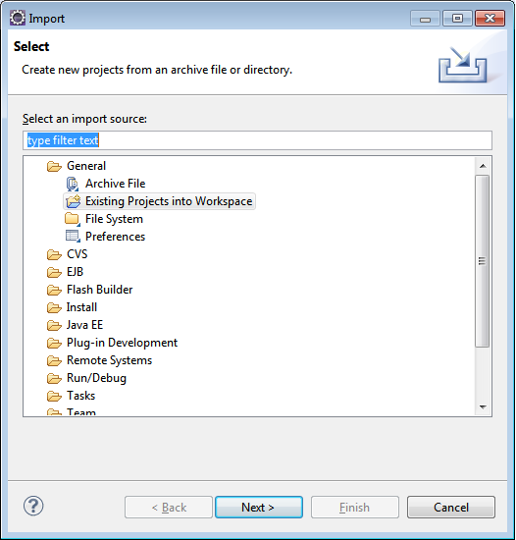

Fig: 2 –Import wizard

1. **Browse the project to be imported. After selecting the project click *Finish* button.**

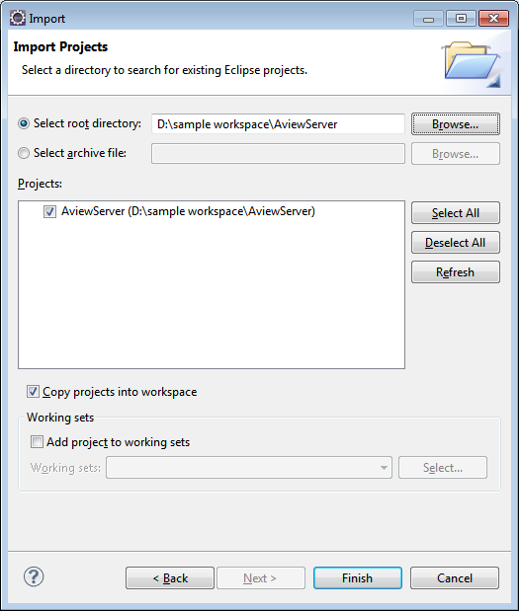

Fig: 3 –Import wizard to select the project

1. **Once the project is imported into the workspace, chances are there for getting compilation errors. If so, there are some setting problems which can be solved by the below steps**

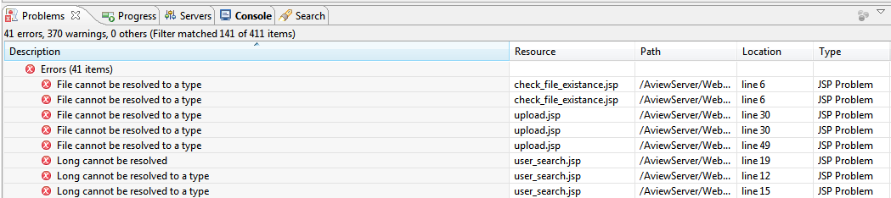

Fig: 4 – Problems view

1. **In Eclipse IDE,right click on the project and select Properties, and click *Java Build Path.* Then go to the *Libraries* tab.**

In the list of library you will see JRE System Library as unbounded (If JRE is not set correctly).

(Refer Fig: 5)

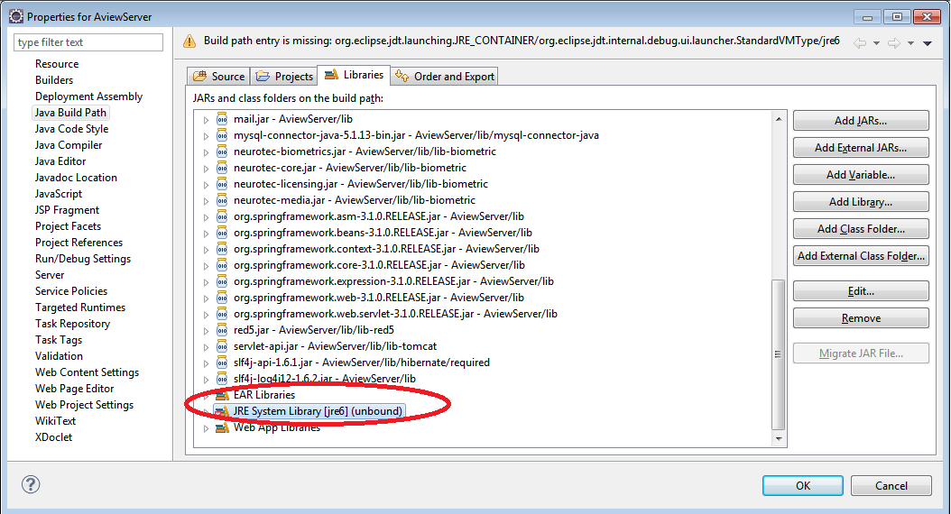

Fig: 5 – Properties

1. **Remove that JRE from the list and click *Add Library* button. (Refer Fig: 6)**

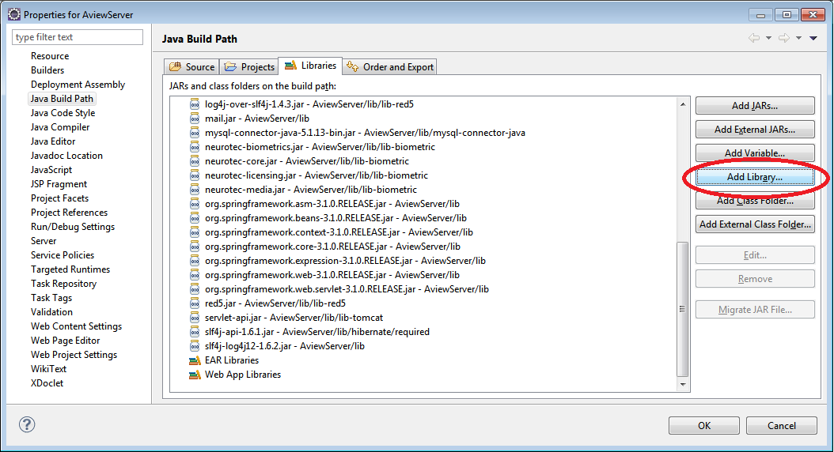

Fig: 6 – Java Build Path

1. **In *Add Library* Wizard, choose *JRE System Library* then click *Next.***

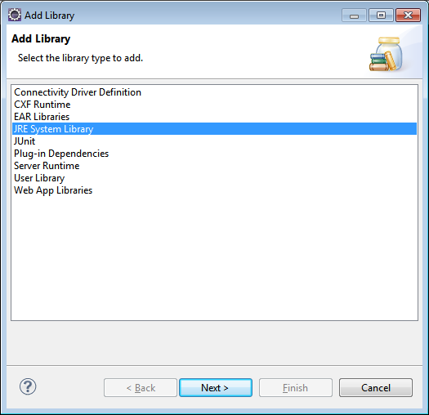

Fig: 7 – Add Library

1. **Select installed JRE and Click *Finish.***

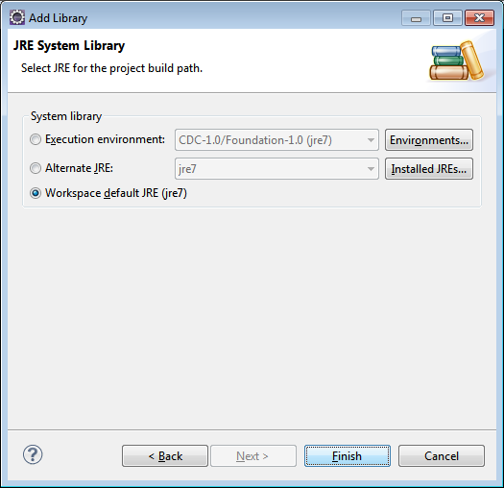

Fig: 8 – Add Library

1. **Install MySql in your development environment for validating the compiled java server.**

Please follow the steps in Section 5.2.1 of this document for configuring the Database.

# Validating the A-VIEW Server within Eclipse

**Step 1**

In Eclipse, take the ***Servers*** view. Do right click on it and choose ***New***, on choosing ***New*** you will get ***Server***. Click on the ***Server*** to get a new window to create new server. (Refer Fig: 1)

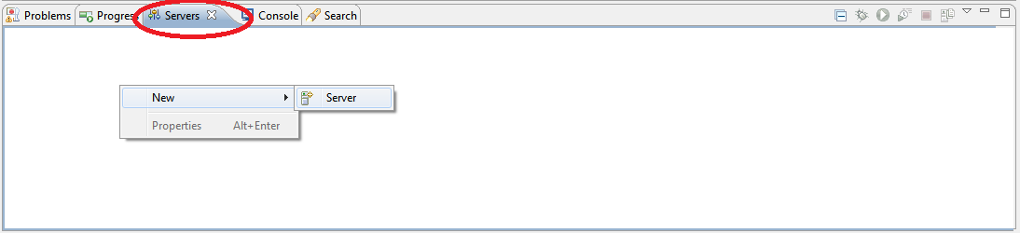

Fig: 9 Starting A-VIEW Server

**Step 2**

Select Tomcat server from ***Apache*** and click ***Next***.

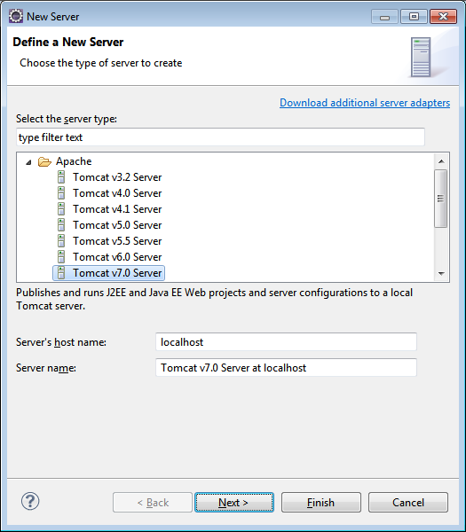

Fig: 10

**Step 3**

Give name to the server (can keep the default).If tomcat is already installed in your machine, provide the tomcat installation directory. Then select your installed JRE and click ***Next***.

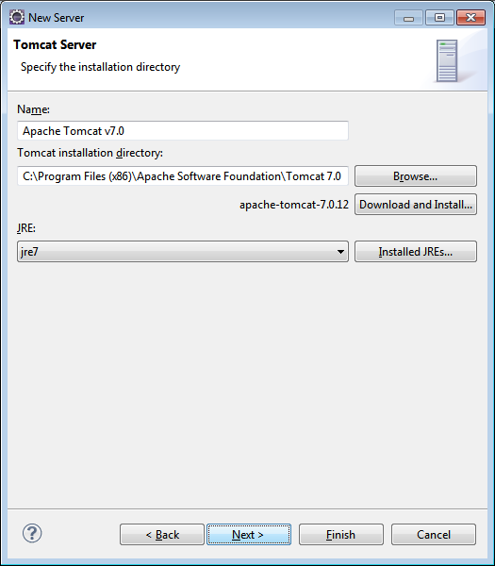

Fig: 11

**Step 4**

Select A-VIEW server from the available list and add it to the configured list. Click ***Next***.

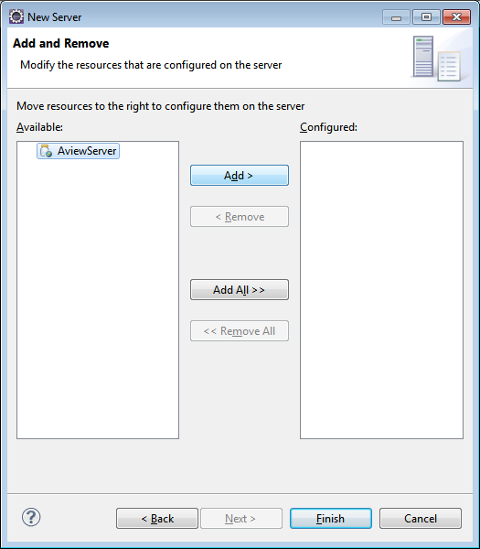

Fig: 12

**Step5**

After adding A-VIEW server to the configured list, click ***Finish***.

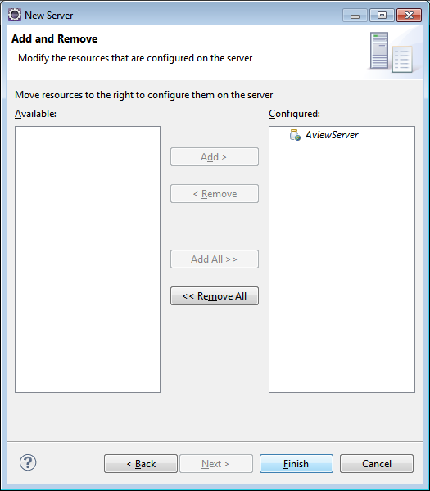

Fig: 13

On clicking ***Finish*** button a new server instance is added. You can see it in the ***Servers*** view.

(Refer Fig: 14)



Fig: 14

**Step 6**

Do right click on the tomcat server instance in the ***Servers*** view and select ***Start.***

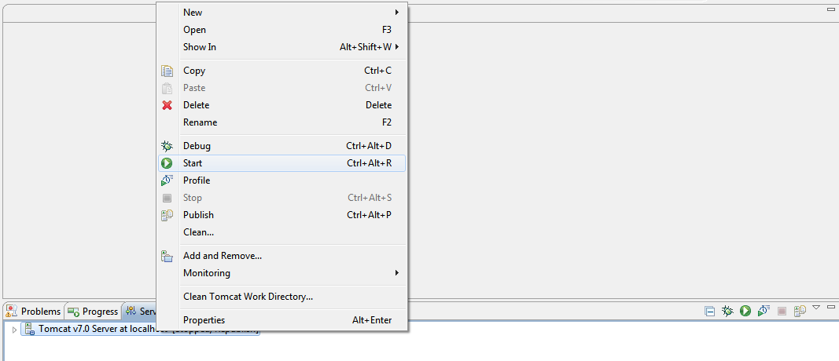

Fig: 15

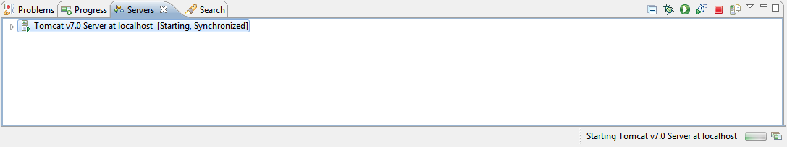

Fig: 16

This time A-VIEW server starts without any previous errors.

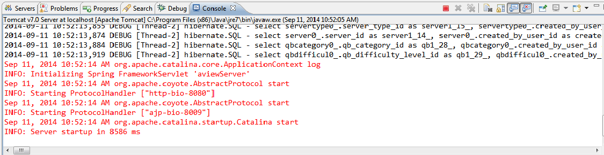

Fig: 17

# To Export the Java code as War file

* Right Click the project and select export war file

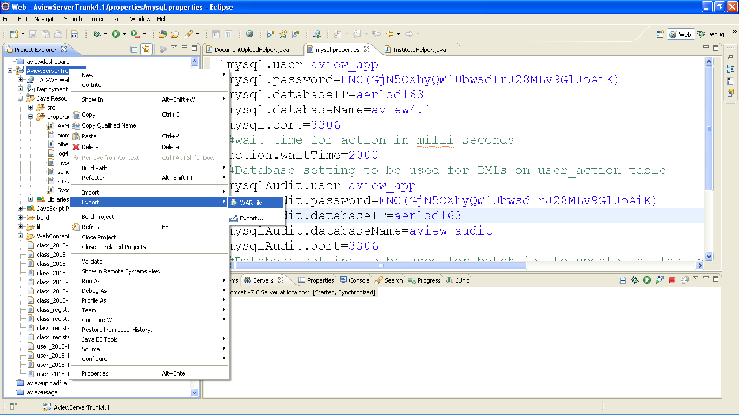

* Export the war file into the Tomcat webapps directory and click on Finish

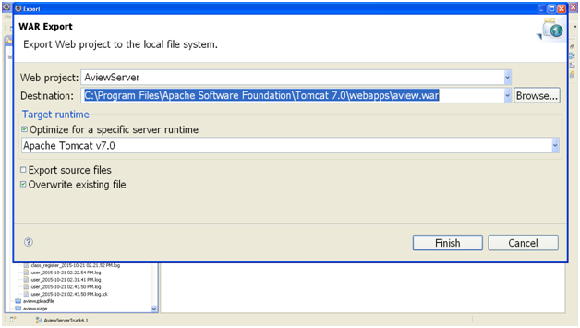

# Installing the various Server Roles

Prior to doing the steps in this Section, it is strongly recommended that you go through and complete the steps given in the Server Pre-Requisites Document. Install the software given in the sections below as appropriate. Configuration instructions are given in Section 5.

## Content Server (Windows)

* + Microsoft Office
  + Adobe Acrobat Reader
  + .NET Framework
  + Apache Web Server (Wamp)
  + ISpring (Optional)
  + Print2Flash

## Video Server / Collaboration Server

* + Apache Web Server (Wamp)
  + [AMS](https://www.adobe.com/products/media-server/download-trial/try.html) / FMS (disable the Http that comes with Fms)

## Java Server & Database Server

* These roles must always be installed on the same computer.
* Install the following software:
  + Mysql
  + Java
  + Tomcat
  + Sqlyog Community Edition

## Special Setup Steps for Windows

* Go to Services, and disable “Application Experience” Lookup Service
* Install the Microsoft Visual C++ 2008 SP1 Redistributable Package (x64)
* Install the Microsoft Visual C++ 2010 SP1 Redistributable Package (x64)
* Perform all security updates

# Configuration Instructions

## Video / Collaboration Server

* During AMS/FMS installation, specify a password for Administrator Logon.
* Ensure that Port 1935 is configured and enabled.
* Do not install the Apache Server that comes with FMS/AMS (or ensure that it uses a port different from Tomcat/Wamp, in case you are doing all-in-one install).
* Copy all the contents of the aview-video-fms folder (created locally by cloning) into the **applications** sub-directory of the FMS/AMS installation directory.

## Java Server & Database Server

## Java Configuration

Make sure the JAVA_HOME and JRE_HOME environment variables are set. The Windows example is given below:

To set JRE_HOME:

a. Right Click on Computer menu and click Properties.

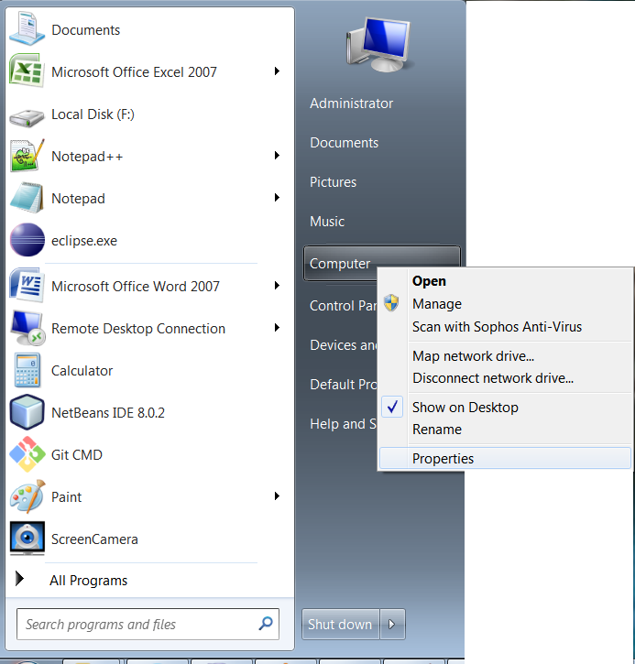

b. Click on Advanced System Settings open a new dialog box.

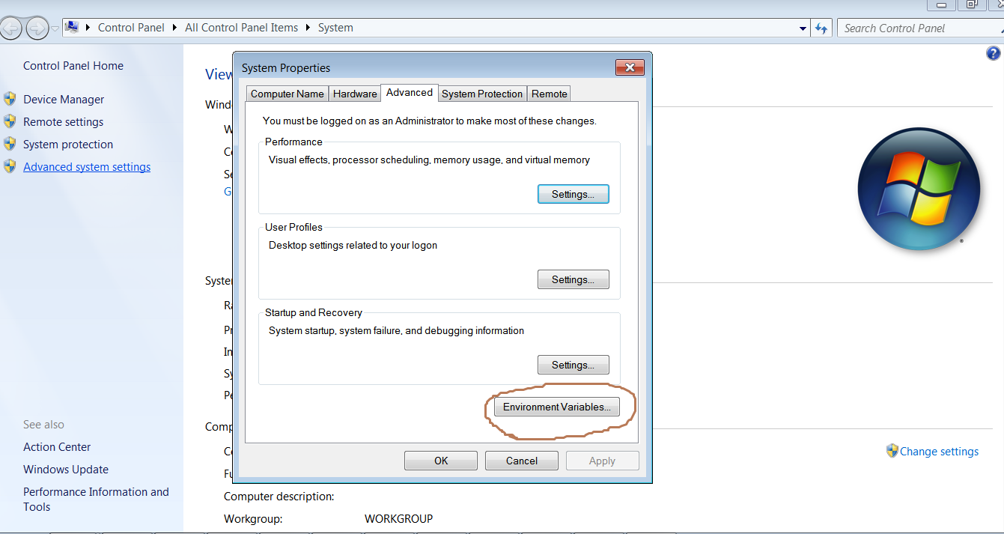

c. Click on "Environmental Variables" button, opens a new Dialog box where one can see the list of existing Environmental Variables. Click on "New" and create one for JRE_HOME by pasting the correct path in the "Variable value:" Click on Ok and close all the other dialog boxes.

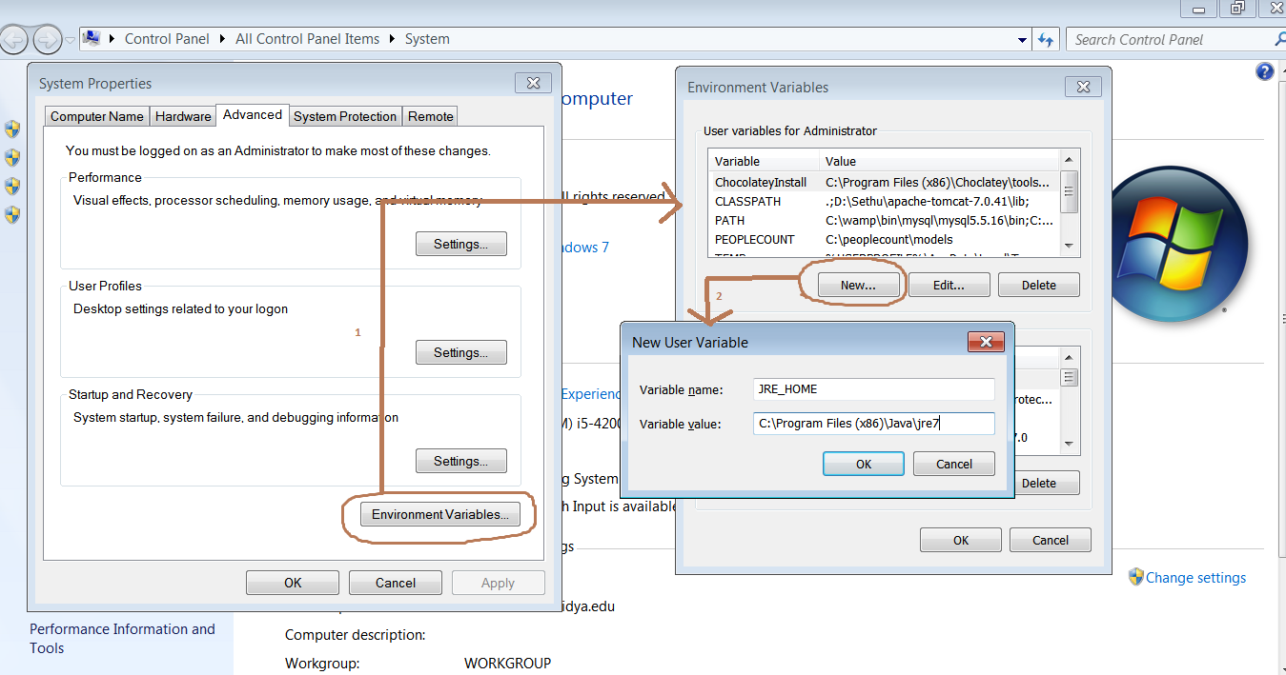

To set JAVA_HOME, follow same instructions as above, and use variable name as JAVA_HOME:

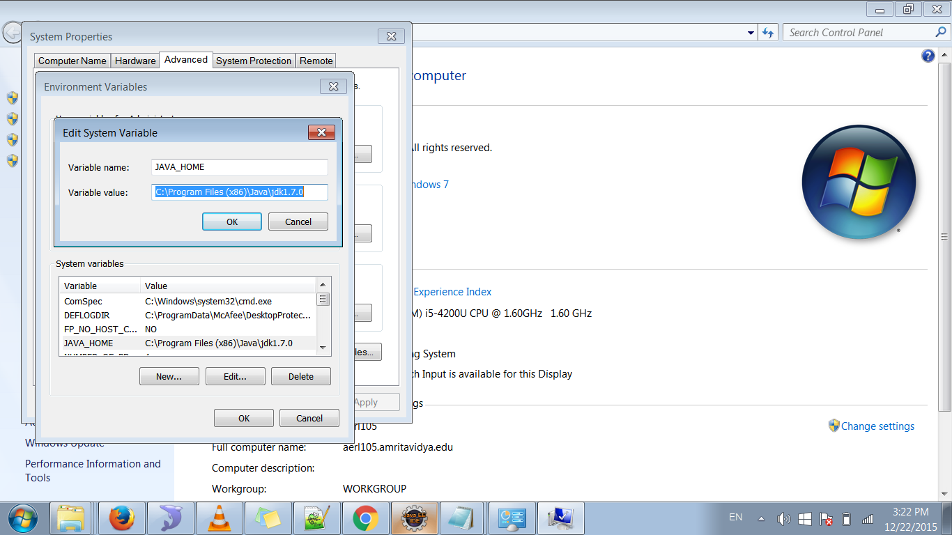

## Mysql Configuration

* Choose Typical Installation and Standard Configuration during MySQL Installation
* Edit **my.ini** and add the following line under [mysqld] and [mysqldump]

max_allowed_packet=100M

* Edit aview.sql and specify the password for the Master Administrator. By default the Master Administrator user name is set to ‘administrator’ with a password of ‘administrator’. You can edit this and set the password to any value you like. This is the first account to be used for logging into the A-VIEW client.
* Now, run the aview.sql and aview_audit.sql scripts. These create the necessary tables in the aview and aview_audit databases.
* Run the aview_configure.sql script. This configures the database so that A-VIEW Java Server can connect to it.
* If you are not running all-in-one server, then you need to provide the Computer Name (IP address or Fully Qualified Domain Name) of the FMS Server in the system_parameter table. To do so, run the following query after changing the localhost below to the correct value:
  + update system_parameter set parameter_value=”localhost” where parameter_name=”OnlineUserDirectoryServer”
* Then add an entry to the servers table for each Server in your deployment as below:

insert into server (server_name, server_ip, status_id, created_by_user_id, created_date, modified_by_user_id, modified_date, server_domain, server_category, supports_animation) values ('localhost','127.0.0.1',1,(select `user_id` from `user` where user_name = 'administrator'),NOW(),,(select `user_id` from `user` where user_name = 'administrator'),NOW(),'localhost','FMS','Y');

Replace ‘localhost’ with your computer name (full name), and 127.0.0.1 as your server’s IP address. If you are using multiple Servers then add an entry for each Server.

## Tomcat

* Set Automatic startup of the service for Windows
* Configure it to use port 9080 for HTTP
* Copy aview.war file from the Development environment to webapps folder of Tomcat
* Restart the Tomcat service

## Content Server

## Wamp (Apache Web Server)

* Disable MySql that comes in this package (for all-in-one configuration)
* Set Automatic startup of the service
* Change user account in service to Administrator
* Edit httpd.conf as follows

Options Indexes

#Require local

Allow from All

Listen 8080

ServerName localhost:8080

* Copy the entire contents of the aview-content-php repository (after cloning locally)into the wwwsub-directory of the WAMP installation directory.

## PHP (Content Server)

* Edit php.ini and set the following parameters:.

max_execution_time = 300

max_input_time = 120

post_max_size = 100M

upload_max_filesize = 100M

## Print2Flash

* Change the service user name to Administrator (for shared storage)
* Default Document Options:
  + Open the Print 2 Flash application.
  + Select the Options->Default Document Options menu
  + Uncheck all the check boxes, Set Back/Forward button combo boxes to ‘Off’, Skin combo to <no skin> as shown below
  + Click ok

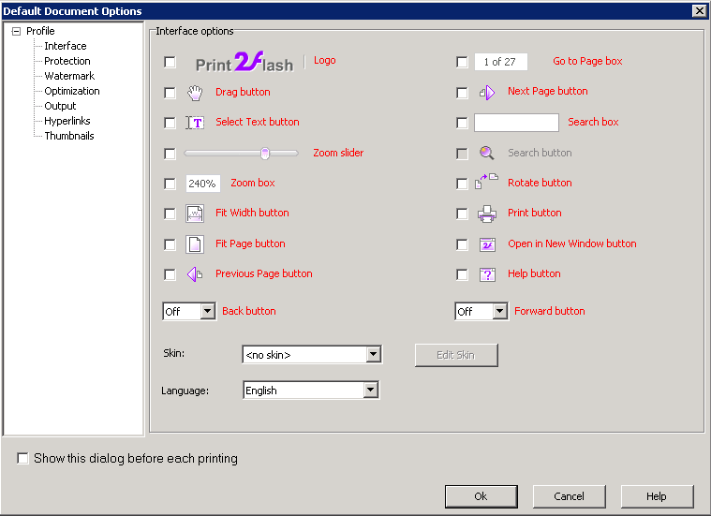

* + In Output: Single File Per page setup for AVIEW
* Set the license information
* P2F as Service: Install P2F service and setup to start automatically.
  + Use Administrator username
  + Grant Permissions to all.
* For running P2F as service, open the P2F application. Click on the Options menu which shows the below dialog. Enter administrator user name and password (of the Desktop) to run as service.

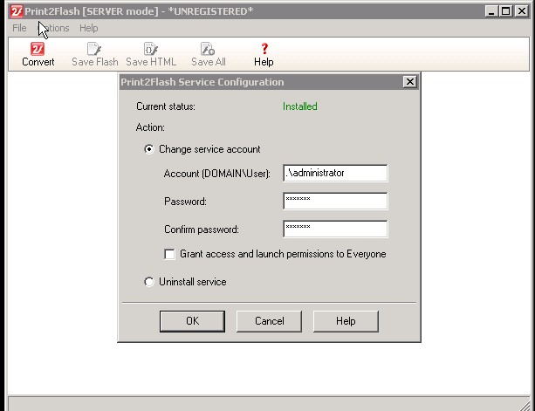

## Speedtest (Optional)

* Install speedtestmini.zip uncompress the file in /wamp/www/speedtest directory and rename index-php.html to index.html